Halloween

Tonight, I am in costume. I chose it, but I don’t like it. It is the costume of hurt. It is the costume of righteous anger. I feel separate and isolated from people I love. I don’t feel I can count on their love.

My costume looks like this:



[This Photo](http://tomfit247.com/2014_02_01_archive.html) by Unknown Author is licensed under [CC BY-NC-ND](https://creativecommons.org/licenses/by-nc-nd/2.0/)

And I vacillate between this costume: and thisand at times I just want to scream.



[This Photo](http://beccarama.com/2010/06/17/the-world-may-be-virtual-but-the-hurt-feelings-are-real) by Unknown Author is licensed under [CC BY-NC-ND](https://creativecommons.org/licenses/by-nc-nd/3.0/)



[This Photo](http://diaryofablacklesbian.blogspot.com/2012/08/the-anger-disappointment-hurt-i.html) by Unknown Author is licensed under [CC BY-NC-ND](https://creativecommons.org/licenses/by-nc-nd/3.0/)



[This Photo](http://www.globalawareness101.org/2010/11/here-is-recap-of-my-day-yesterday.html) by Unknown Author is licensed under [CC BY](https://creativecommons.org/licenses/by/3.0/)

but basically, I feel down. Alone. I would like to feel happy- I try to think just happy thoughts, but I seem to have no control over my thoughts and feelings. It isn’t that simple. Or maybe it is, and I am just too stubborn to change. And sometimes I actually do feel like this, but only temporarily!

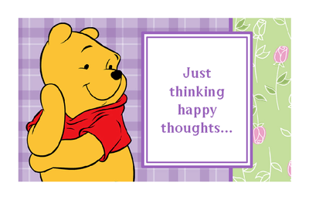

I remember what I was told- “Everyone wants to be judged by their intentions, but we judge others by their actions”. And I realize I have judged someone by their actions and not by their intentions. I have done this because I feel vulnerable, and am sensitive. I have done this because I am afraid of losing a close friendship. I have given meaning to what was said and not said, and am projecting my worst fears about what it can mean for the future. And by expressing this fear, I have made things worse. I have “disappointed” someone I care about. And by judging them, I have judged myself and made myself feel miserable.



But perhaps my mistake is wanting to be a “special” friend. Costume of my dreams! I should not count on people to understand me, make me happy, or see my worth. If I continue to do this, I will always be disappointed. The world is my projection, and if I am uncertain about my worth at some deep level, I will always find proof of that in other people. Of course, it would be great if a friend would love me when I forget to love myself- It isn’t that this is asking too much, it is just that this is not possible. No one can love me enough if I forget I am lovable. And I need to remember sometimes they feel hurt too, and so they defend or attack or both. Like me.

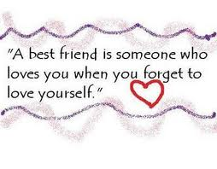

And how am I different from most humans? Not at all. We are all feeling separate from our Loving Source, and we have all forgotten who we really are. We are all dressed as someone other than our True Selves, other than an extension of God, other than Love. And when we perceive ourselves as that false self, we then see it reflected in others. Others seem unjustly hurt or hurtful. Others seem unjustly sad and angry- at us. Others seem like they are screaming- at us. Others seem disappointed and sad- at us. But we are only looking at the mirror. And the frustration and anger come from not forgiving ourselves for what we see in the mirror. A projection. For not being kind to ourselves. For not realizing God’s love. We are often “beside ourselves”.



I realize it isn’t just about “thinking happy thoughts”. About willing myself not to feel hurt. About hoping others will be more sensitive, or more loving, or whatever I want. I can’t force myself to think differently.

It is about awakening. About loosening my attachment to the Ego’s false ideas of separation. It is about receiving God’s grace for me, by me. It is about forgiving ourselves for the crazy idea we have that we are not good enough, not smart enough, not deserving enough, (fill in the blanks, these are some of mine! etc etc) . - those childhood ideas we either heard or thought. Not smart enough for what? For who? For what purpose? And our responses- the anger, the running away, the lashing out, the quietly retreating, the proving I am good, etc etc- all those defenses that we learned to protect ourselves as children- they do not protect me anymore. They just put the locks on the jail that is me inside my mind. These thoughts, these false ideas, attack others and myself. Knowingly or unknowingly. They are not the Peace of God, and they do not teach the Peace of God. They feel like hell! My most unfavorite costume!



But what about the past? Ah- I get it- the past is the past. And I cannot control what others think or how they interpret the past. I can only control how I see the past. If I forgive, I will know the truth. No one is powerful enough to hurt my spirit in truth, nor am I powerful to hurt another in truth. I am powerful enough, though, to think I can hurt myself or others. Leave it to my Ego, my heavy costume! 

So how am I going to change my mind? Change my costume? I cannot do it myself. I cannot do it with my own thoughts, because those thoughts are of my ego- which by the way looks like all the costumes above! Including the “thinking happy thoughts” costume!

I will just have to put on the costume of the person who takes the right road- the one who asks which is the right road? And to remember to STOP—and ask for help.



[This Photo](http://www.flickr.com/photos/wingedwolf/5471047557/) by Unknown Author is licensed under [CC BY-NC-ND](https://creativecommons.org/licenses/by-nc-nd/2.0/)

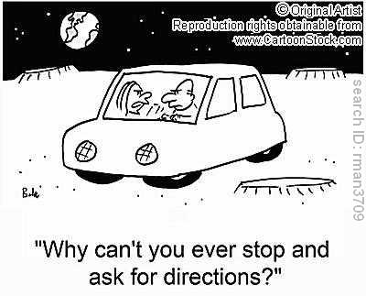

I will have to remember to ask for directions from One who Knows. Please, help me to see it differently. Please help me to choose again. Please help me to see only Peace, and nothing else. Please please please….help me to see the Truth. Help me to transform my Ego’s thoughts to that of only Love. Please let me recognize that what does not look like love is a call for help- and include myself. This is my prayer tonight. This is the costume I choose to wear for this Halloween. The costume of transformation.

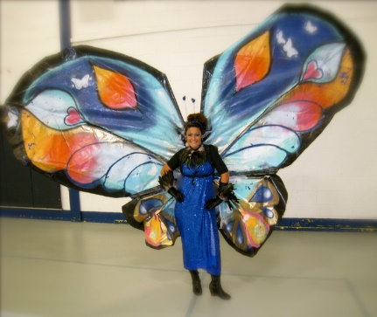

[This Photo](http://www.amarettogirl.com/blog/2009/10/31/no-sew-butterfly-costume.html) by Unknown Author is licensed under [CC BY-ND](https://creativecommons.org/licenses/by-nd/3.0/)